**23. Dropdown navbar and positions**

1. Knowing the basics is good enough, but eventually we are going to move to Tailwind CSS.

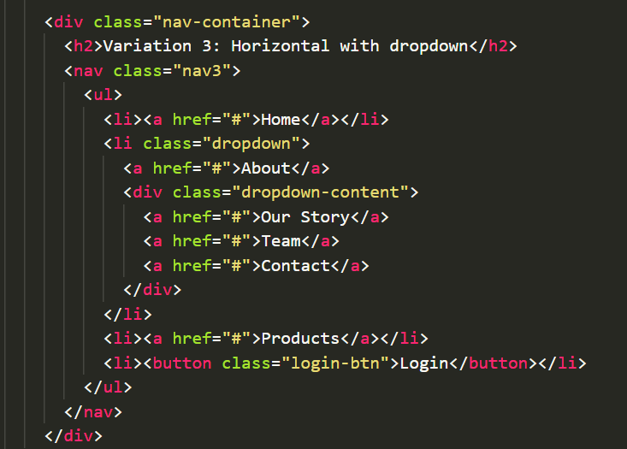

2. Here are going to write code for hover-dropdown navbar effect, but the click-navbar effect comes with the help of Javascript.

* Selecting the whole nav3 body, giving it a light blue bgc color and a padding of 10px.

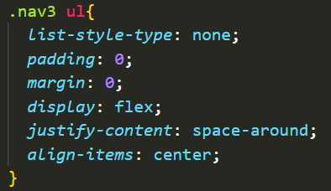

* By selecting the “ul” element, we make the li elements go horizontal, space-around(justify-content) & center(align-items). Also, removing the padding & margin.

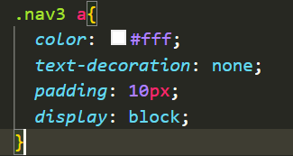

* Now, we go ahead and select the anchor tag(a tag), make text-xolor white and remove the underline below anchor elements using text-decoration: none;. We induce some padding and make the display block, so that each of the anchor elements are on separate line.

Before “display:block;” :

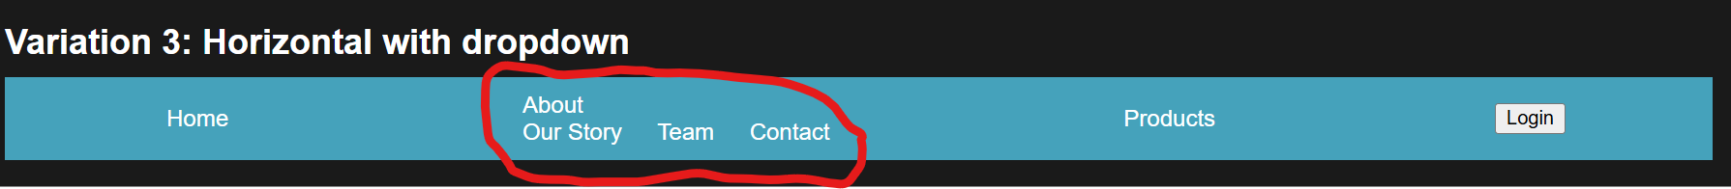

After “display:block;”

* To get a hover effect when hovered over “About “anchor tag/nav-element, we:

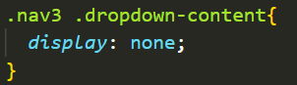

1. In default mode, we stop showing dropdown section by setting “display: none;”

2. And then, we only show dropdown section when “about” anchor tag is hovered-over by using “.dropdown:hover” selector component. “display: block;” undoes the effect of “display:none;”, as a result we will be able to see the dropdown section when “about” nav element is hovered.  
Also, without “position: absolute;”, when we hover the about nav element, the whole of navbar is extended vertically to make space for the dropdown section. As shown below in the picture.

* With “position:absolute” the dropdown section is ripped from the navbar element i.e. separated (and is actually capable being placed wherever we want it to) and is shown separately whenever “about” nav element is hovered over.

* We give a min. width to the dropdown section by using “min-width” property, setting “min-width:150px;” .

